**Deployment Core App on Windows & Linux**

**Step 1:** Download hosting bundle from the below link and install at your system.

<https://github.com/dotnet/core/blob/master/release-notes/2.2/2.2.6/2.2.6.md>

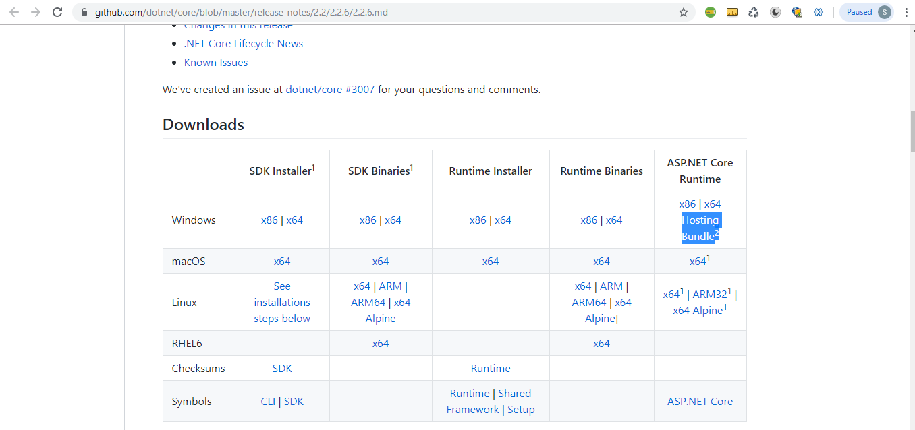

**Step 2:** After installing hostable exe, open turn windows feature on or off from Control panel and enabled **IIS hostable web core**

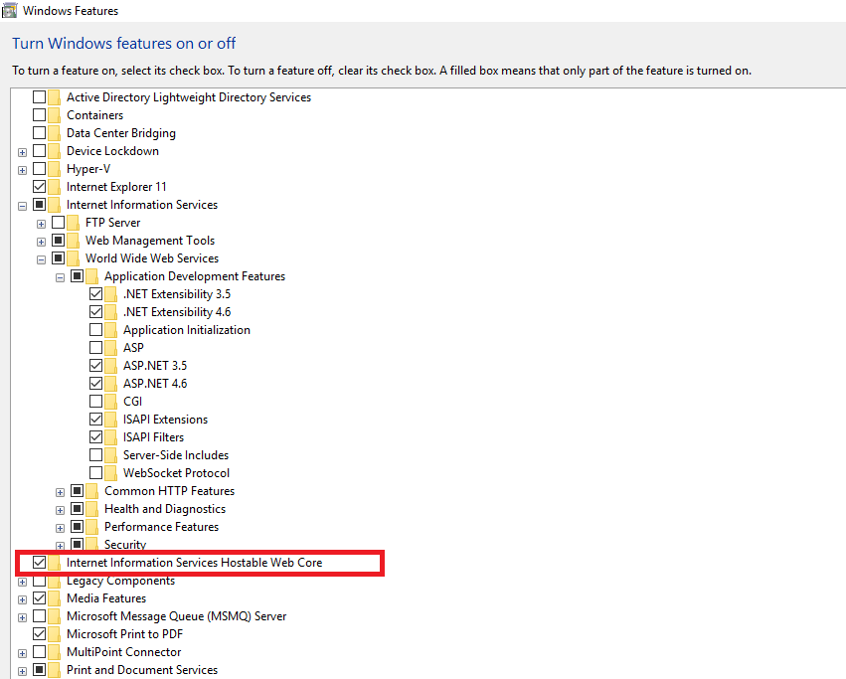

**Step 3:** type **inetmgr** command in run window and create your web app on IIS and configure your published folder path during the app creation.

Or you can directly host in a default web site folder under wwwroot folder.

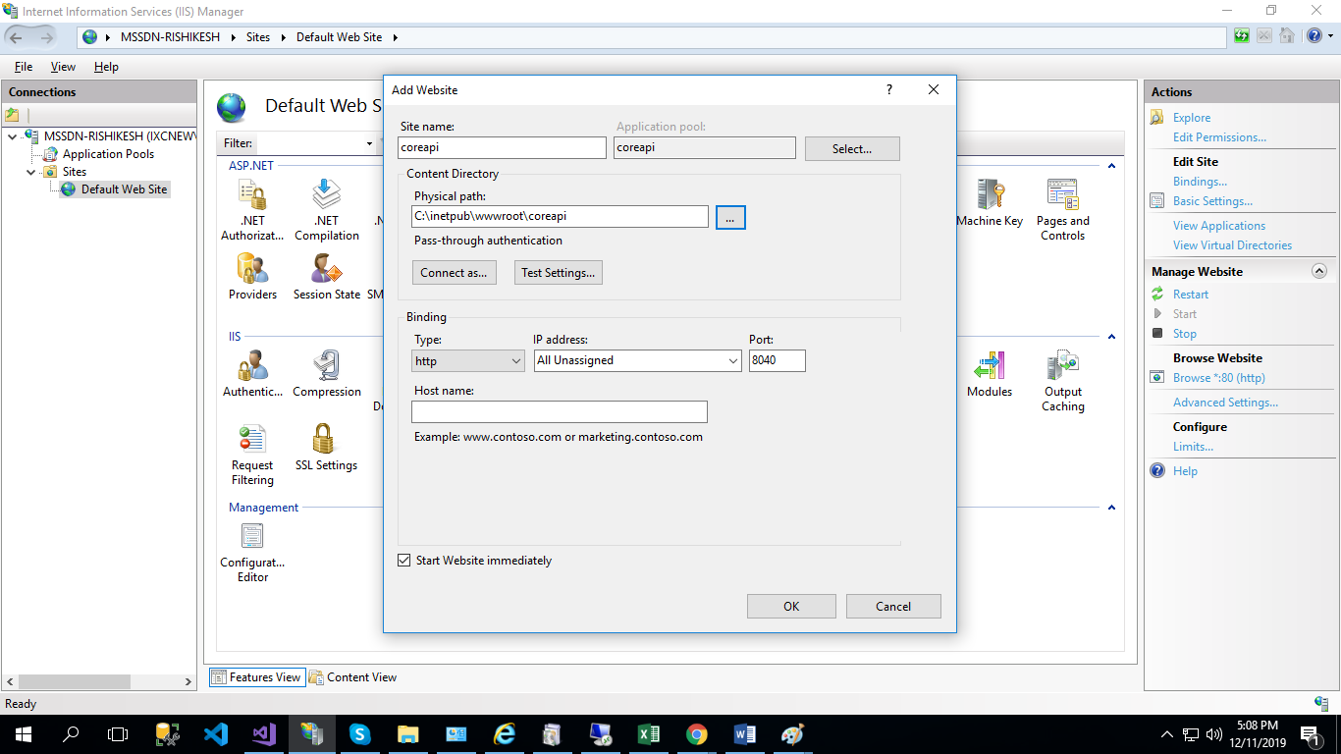

**Step 4:** After creating app on IIS, you can check you core app hosting with “Browse” link in left panel in feature view and don’t forgot to append /swagger in browser url because we create empty core app.

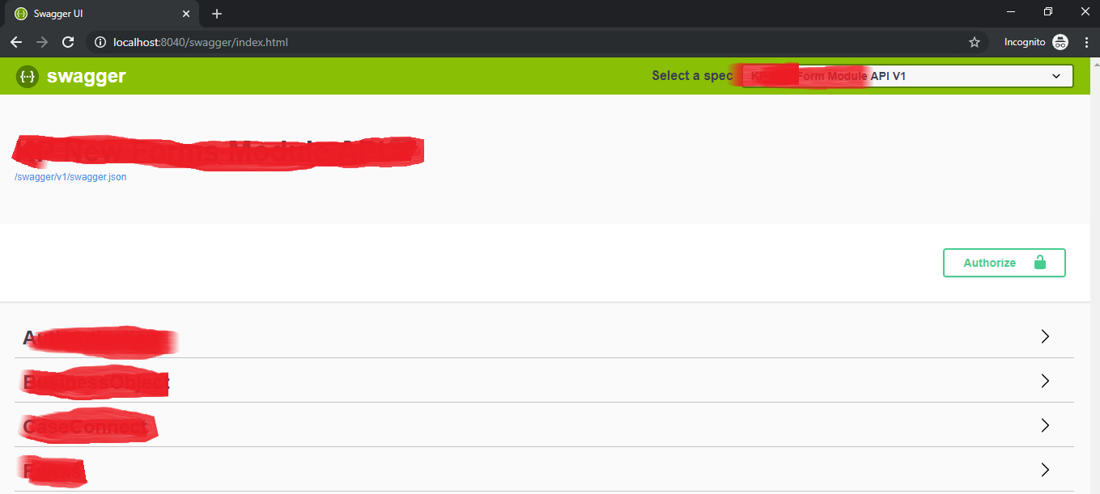

**Deployment on Linux System**

**Step 1:** Run this command once at per machine.

wget -q [https://packages.microsoft.com/config/ubuntu/19.04/packages-microsoft-prod.deb -O packages-microsoft-prod.deb](https://packages.microsoft.com/config/ubuntu/19.04/packages-microsoft-prod.deb%20-O%20packages-microsoft-prod.deb) sudo dpkg -i packages-microsoft-prod.deb

**Step 2:** Install .Net core SDK by using below command.

sudo apt-get update

sudo apt-get install apt-transport-https

sudo apt-get update

sudo apt-get install dotnet-sdk-3.1

**Step 3:** Install ASP.Net core runtime by using below command.

sudo apt-get update

sudo apt-get install apt-transport-https

sudo apt-get update

sudo apt-get install aspnetcore-runtime-3.1

**Step 4:** Install .Net core runtime by using below command.

sudo apt-get update

sudo apt-get install apt-transport-https

sudo apt-get update

sudo apt-get install dotnet-runtime-3.1

**Step 5:** After executing all above command create new folder through **mkdir <FolderName>**

**Step 6:** Go to your folder using **cd** **<FolderName>**  and take clone of your core project.

**git clone https://github.com/rishikeshkumar25/dockercore.git**

**Step 7:** Move to your Coreproject folder using **cd Coreproject** and run below command to publish your core application.

dotnet build  
dotnet publish -o <Publish_FolderName>

**Step 8:** Again move to publish folder using **cd** <**Publish_FolderName>** and execute **dotnet run** command to view in browser.

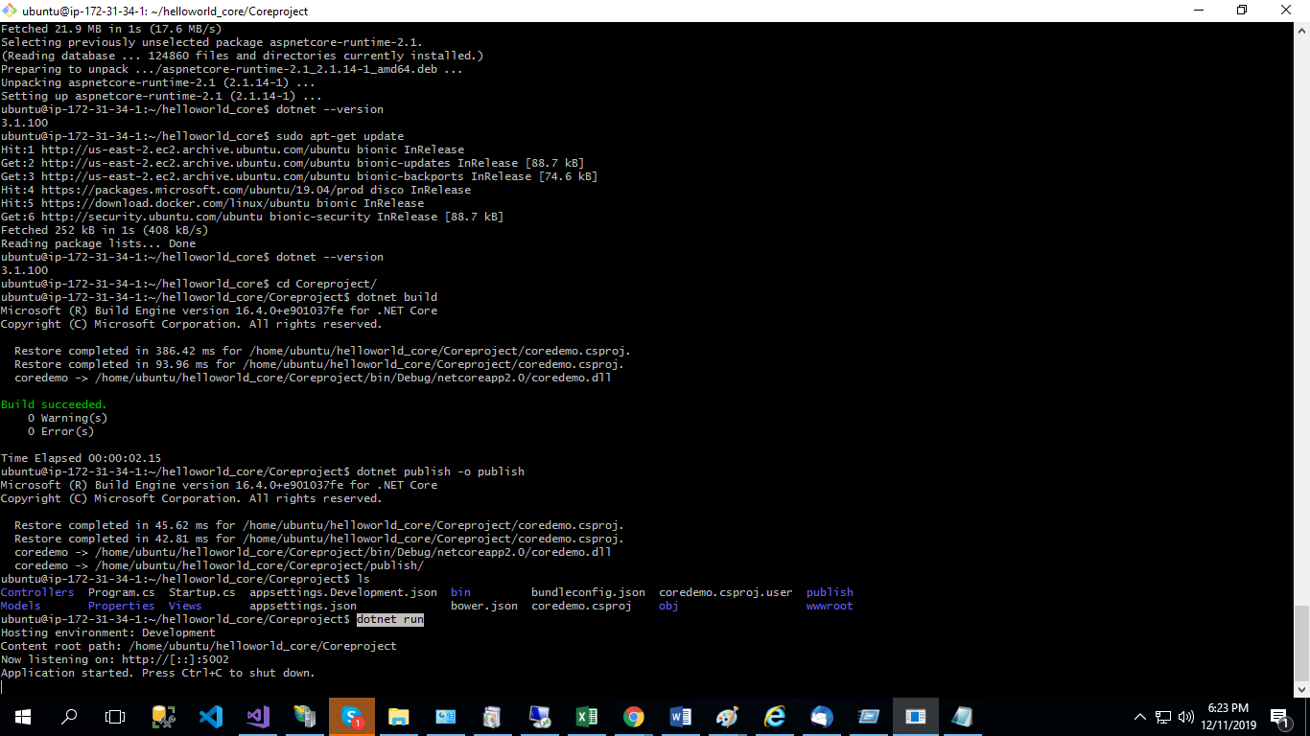

**\*\*\*\*\*\*\*\*\*\*\*\*\*\*\*\*\*\*\*End\*\*\*\*\*\*\*\*\*\*\*\*\*\*\*\*\*\*\***